**TECHFEST 2021-22**

**RESEARCHER DISCOVERY PLATFORM**

**Team Details:**

**Team ID:** RD-216466

**Team Members:**

|  |  |
| --- | --- |
| Name | Qualification |
| Anirudh CP | Second Year, VIT Chennai |
| Roshan Philip Jacob | Second Year, VIT Chennai |
| Dr. Rajakumar Arul | Professor, VIT Chennai. |

**Objective:**

Develop a tool that can autonomously identify faculty & researchers in a given area of research. The tool must also generate their profiles using the provided template.

Teams are encouraged to design a comprehensive approach that includes scanning from academic institutions and other websites, integration with open-source repositories like google scholar, google patent, semantic scholar, and interfacing with relevant service providers.

**Inferred Objective:**

Scrape through a reputed source such as Google Scholar to get research articles in a given domain. Cross-reference the article with the authors involved. Extract the author names and qualifications and provide a search link to obtain more information about the given author.

**Plan for Next Round:**

We intend on scraping more websites and scaling the algorithm. We can increase the reliability and volume of information we extract from them.

**Work Breakdown Structure:**

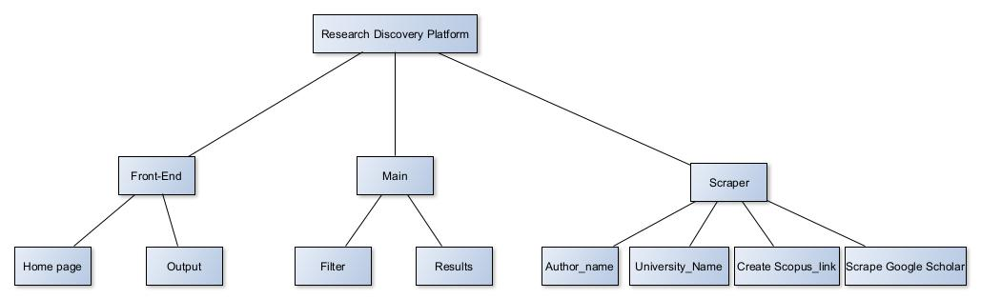

The application is split into the front-end, the main processing module and the scrapers module. The front-end delivers the user interactivity in the form of a home page and an output page. The main process module is responsible for filtering relevant information from the websites.

The scrapers module is responsible for providing the tools required to scrape the information needed from the website. The create Scopus link is responsible for creating a direct search query to the author required.

**Flowchart:**

